**FLOOD MONITORING AND EARLY WARNING SYSTEM**

**TEAM MEMBER**

**962121104001 : ABHIJITH .J**

**Phase 5 submission document**

**Project Title: Flood Monitoring System**

**Phase 5: Project Documentation And Submission**

**Topic:** *In this section we will document the Flood Monitoring and Early Warning project and prepare it for submission.*

**FLOOD MONITORING SYSTEM**

**INTRODUCTION:**

* Floods pose a significant threat to both human lives and property, necessitating the development of advanced monitoring and early warning systems.
* This project presents a comprehensive Flood Monitoring and Early Warning System (FMEWS) designed to minimize flood-related risks and enhance disaster preparedness.
* FMEWS integrates various modules and technologies to collect real-time data, analyze flood conditions, and issue timely warnings to at-risk communities.
* This paper outlines the key modules that constitute FMEWS, illustrating their functions and interactions to create a robust and effective flood management solution.

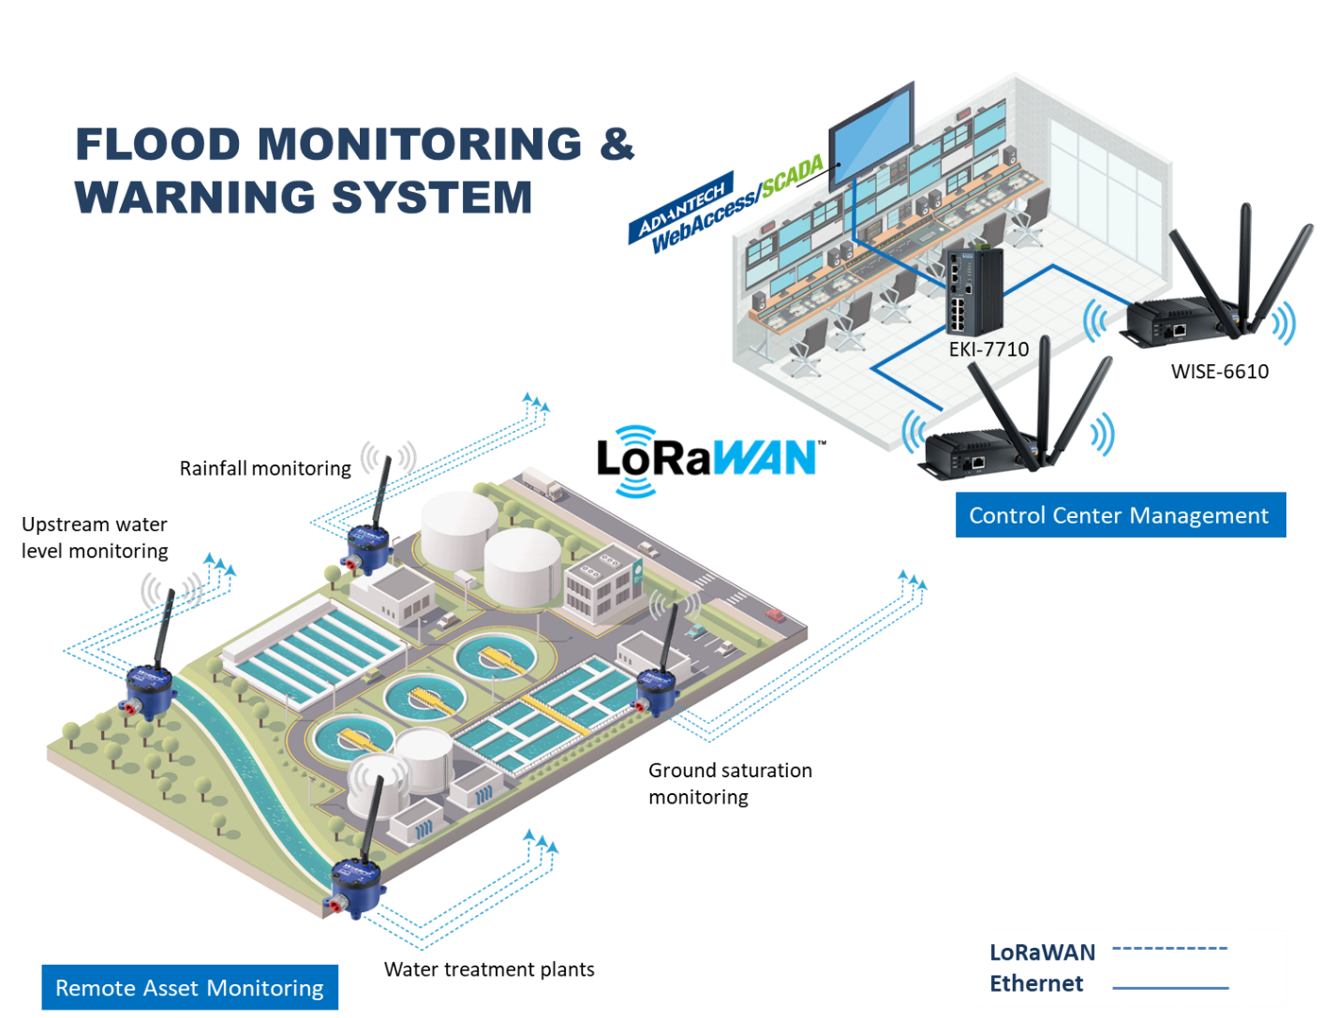

* To mitigate these risks and provide early warnings to affected communities, flood monitoring systems play a vital role.
* These systems are a combination of technology, data collection methods, and communication networks designed to continuously track and predict flood events.
* In this introduction to flood monitoring systems, we will explore their importance, key components, and their role in safeguarding communities.
* Incorporating predictive modeling into flood monitoring and early warning systems is crucial for improving the accuracy and timeliness of flood predictions, as well as for mitigating the impacts of floods
* Historical flood data refers to records, information, and data collected over time that document past instances of flooding events.
* This data is crucial for various purposes, including flood risk assessment, floodplain management, infrastructure planning, and the development of predictive models for flood monitoring and early warning systems

Dataset Link: <https://www.kaggle.com/code/mukulthakur177/flood-prediction-model/input>

**Given Dataset:**

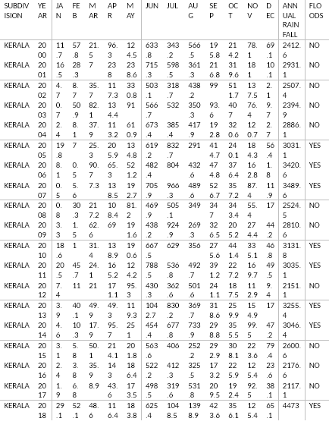

**PROJECT'S OBJECTIVES**

The objectives of a flood monitoring and early warning system are to provide timely and accurate information to help mitigate the impact of flooding on communities and the environment. These systems aim to achieve the following objectives:

* **Early Detection:** Detect the onset of potential flooding as early as possible to provide sufficient lead time for preparation and response.
* **Real-time Monitoring:** Continuously monitor water levels, weather conditions, and other relevant data to provide up-to-the-minute information.
* **Risk Assessment:** Assess the potential risk of flooding in different areas based on historical data, current conditions, and predictive models.
* **Public Safety:** Protect human life by issuing timely and effective warnings to residents, businesses, and travellers in flood-prone regions.
* **Property Protection:** Minimize damage to property and infrastructure by providing advance notice to property owners, allowing them to take protective measures.
* **Environmental Protection:** Protect and mitigate harm to the natural environment, including wildlife and ecosystems, by issuing warnings and taking proactive measures.
* **Infrastructure Resilience:** Support infrastructure resilience by providing data and information that can inform the design and maintenance of roads, bridges, and other critical infrastructure in flood-prone areas.
* **Economic Impact Reduction:** Reduce the economic impact of floods by allowing businesses and industries to prepare for and mitigate the effects of flooding.
* **Coordination and Communication:** Facilitate communication and coordination among government agencies, emergency responders, local authorities, and the public during flood events.
* **Education and Awareness:** Educate the public about flood risks, preparedness, and the actions they should take when flood warnings are issued.
* **Resource Allocation:** Assist in the allocation of resources, such as emergency personnel and supplies, to areas in need during a flood event.
* **Data Collection and Analysis:** Gather and analyze historical and real-time data to improve flood prediction models and better understand flood patterns.
* **Community Engagement:** Engage with local communities and stakeholders to ensure that the early warning system meets their specific needs and provides valuable information.
* **Continuous Improvement**: Evolve the system over time by incorporating new technologies, improving prediction models, and expanding the coverage area.

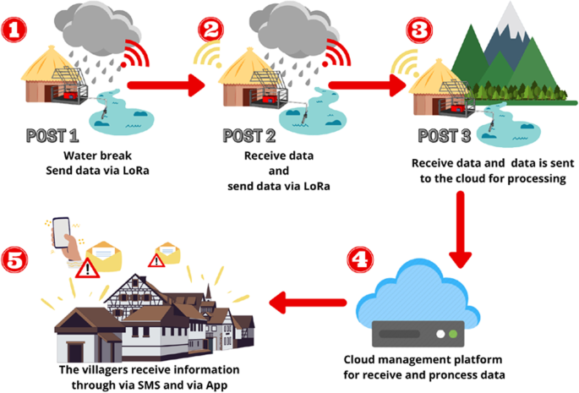

Flood monitoring and early warning systems play a vital role in public safety, disaster preparedness, and response. Their objectives are centered around saving lives, protecting property, and minimizing the impact of flooding on both human and natural environments.

**IOT SENSOR DEPLOYMENT**

Deploying IoT sensors for flood monitoring and early warning involves a well-thought-out plan and consideration of various factors to ensure accurate data collection and timely warnings. Here's a step-by-step guide for IoT sensor deployment in flood-prone areas:

1. **Identify High-Risk Areas**: Determine flood-prone regions where sensor deployment is most critical. This may include areas near rivers, coastal zones, low-lying areas, and urban centers susceptible to flash floods.
2. **Sensor Selection:** Choose appropriate sensors based on the specific monitoring needs of the area. Common flood monitoring sensors include water level sensors, rainfall sensors, weather stations, and soil moisture sensors. Consider the following factors:
   1. **Sensor type:** Select sensors suitable for the target environment and water level measurement needs.
   2. **Accuracy and precision:** Ensure sensors provide accurate and reliable measurements.
   3. **Connectivity:** Choose sensors with communication capabilities compatible with the IoT network (e.g., LoRa, cellular, Wi-Fi).
   4. **Power source:** Decide between battery-powered or wired sensors, considering maintenance and power requirements.
   5. **Data transmission frequency:** Determine how often sensor data should be transmitted (real-time or periodic).
3. **Sensor Placement:** Install sensors strategically in flood-prone areas to capture critical data. Consider factors such as proximity to water bodies, elevation, and accessibility for maintenance. Ensure the sensors are securely anchored to prevent displacement during flooding.
4. **Communication Infrastructure**: Set up a communication infrastructure to transmit data from sensors to a central data collection point. Common options include LoRaWAN, cellular networks, Wi-Fi, or satellite communication. Choose the technology that suits the coverage area and data transfer requirements.
5. **Data Collection and Storage:** Establish a central data collection and storage system to receive, process, and store sensor data. Consider cloud-based solutions for scalability and data redundancy.
6. **Power Supply:** Ensure that sensors have a reliable power source. Battery-powered sensors should have a sufficient power reserve, and wired sensors should be connected to a stable power supply.
7. **Data Validation and Quality Control:** Implement data validation processes to detect anomalies and ensure data quality. This is crucial for accurate flood prediction.
8. **Real-time Monitoring:** Set up a real-time monitoring system to continuously track sensor data and identify trends or anomalies. This may involve dashboard visualization and alerts for unusual data patterns.
9. **Data Analysis and Prediction:** Implement algorithms and models to analyze sensor data and predict flood events. Machine learning and artificial intelligence can be valuable for predictive analytics.
10. **Early Warning System:** Integrate the IoT sensor data into an early warning system. Establish thresholds and triggers for issuing flood warnings to relevant authorities and the public.
11. **Testing and Calibration**: Regularly test and calibrate sensors to maintain accuracy. Ensure that sensors and communication systems are functioning correctly.
12. **Community Engagement:** Educate local communities about the sensor deployment and flood monitoring system. Encourage awareness and preparedness among residents.
13. **Maintenance and Updates:** Establish a maintenance schedule to replace batteries, calibrate sensors, and update software and hardware components as needed.
14. **Emergency Response Coordination:** Collaborate with local authorities and emergency responders to establish protocols for responding to flood warnings.
15. **Data Accessibility:** Make sensor data accessible to relevant stakeholders, including government agencies, researchers, and the public, to enhance preparedness and decision-making.
16. **Scalability:** Plan for the scalability of the sensor network as needed to cover a wider area or include additional sensors.
17. **Data Privacy and Security:** Implement security measures to protect sensor data and ensure data privacy compliance.

The deployment of IoT sensors for flood monitoring and early warning requires a comprehensive approach, from sensor selection and placement to data analysis and community engagement. A well-implemented sensor network can significantly contribute to mitigating the impact of floods on communities and the environment.

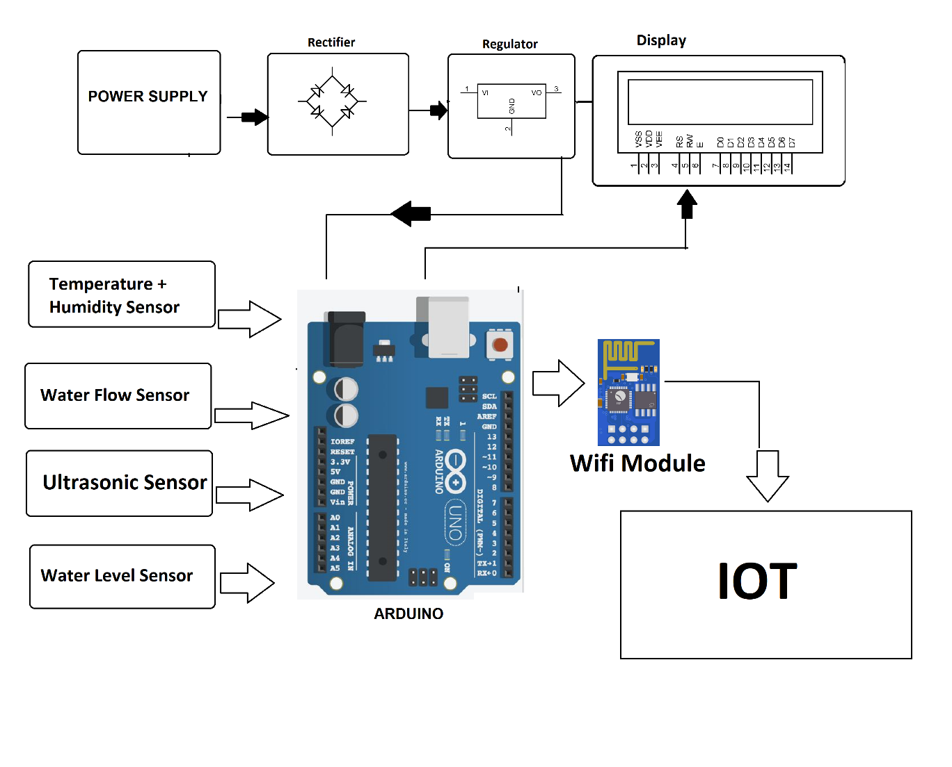

Fig: Deployment of sensors using IoT

**PLATFORM DEVELOPMENT**

Developing a platform for flood monitoring and early warning is a complex but essential task. Such a platform requires a combination of hardware, software, data analytics, and real-time communication capabilities to provide timely warnings and support decision-making during flood events. Here are the key steps and components for developing a platform for flood monitoring and early warning:

**1. Define Objectives and Requirements:**

Clearly define the objectives of the platform, including the scope of coverage, the types of floods to monitor (e.g., river, flash, coastal), and the target audience (public, authorities, emergency responders).

**2. Sensor Deployment:**

Deploy a network of IoT sensors, including water level sensors, rainfall sensors, weather stations, and river gauges, in flood-prone areas. These sensors will collect real-time data.

**3. Communication Infrastructure:**

Establish a robust and reliable communication infrastructure to transmit data from sensors to a central data collection point. This may involve LoRaWAN, cellular networks, satellite communication, or a combination of technologies.

**4. Data Collection and Storage:**

Set up a central data collection and storage system, which can be cloud-based, to receive, process, and store sensor data. Ensure data is securely stored and accessible.

**5. Real-time Data Processing:**

Implement real-time data processing and analysis to monitor and evaluate the incoming data. Algorithms and models can help detect anomalies and predict potential flood events.

**6. Early Warning System:**

Develop an early warning system that integrates with the data processing pipeline. Establish triggers and thresholds for issuing flood warnings to relevant authorities and the public.

**7. User Interface:**

Create a user-friendly web-based dashboard and mobile application for visualizing real-time data, including water levels, weather conditions, and flood warnings.

**8. Notification and Alerts:**

Integrate push notification and alerting mechanisms within the platform to communicate warnings to users, authorities, and emergency responders via email, SMS, or in-app notifications.

**9. GIS Integration (Optional):**

Integrate Geographic Information System (GIS) for mapping and spatial analysis of flood-prone areas and potential impact zones.

**10. Machine Learning and Predictive Analytics (Optional):**

Utilize machine learning and predictive analytics to enhance flood prediction accuracy based on historical and real-time data.

**11. Security and Data Privacy:**

Implement robust security measures to protect the data and ensure data privacy compliance. Encrypt sensitive data and use access controls.

**12. Maintenance and Updates:**

Develop a maintenance schedule for sensor calibration, battery replacement, and software updates to ensure the system's accuracy and reliability.

**13. Public Education and Awareness:**

Educate local communities about the platform's capabilities and the actions they should take when flood warnings are issued. Encourage awareness and preparedness.

**14. Collaboration with Authorities:**

Collaborate with local authorities and emergency responders to establish protocols for responding to flood warnings and coordinate emergency response efforts.

**15. Scalability:**

Plan for scalability to accommodate increased sensor deployment and wider coverage areas as needed.

**16. Compliance and Regulations:**

Ensure the platform complies with relevant regulations and standards related to flood monitoring and early warning systems.

**17. Testing and Validation:**

Thoroughly test the platform in a controlled environment and validate it with real-world data to ensure its effectiveness.

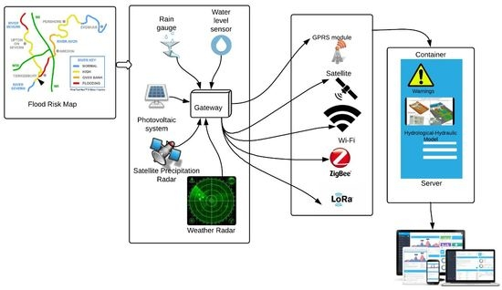

Developing a flood monitoring and early warning platform is a significant undertaking that requires careful planning, technical expertise, and collaboration with various stakeholders. The platform's success can significantly contribute to public safety, disaster preparedness, and response in flood-prone regions.

**CODE IMPLEMENTATION**

The python code to implement a flood prediction model with appropriate output is given below:

**PYTHON CODE:**

import requests

import json

import pandas as pd

import numpy as np

from sklearn.linear_model import LinearRegression

# Define the URL of the flood prediction API

API_URL = "https://example.com/api/flood_prediction"

# Define the function to get the historical water level data

def get_historical_water_level_data():

"""Gets the historical water level data from the flood prediction API.

Returns:

A pandas DataFrame containing the historical water level data.

"""

# Make a request to the flood prediction API

response = requests.get(API_URL)

# Check if the response was successful

if response.status_code != 200:

raise Exception("Failed to get the historical water level data from the flood prediction API.")

# Parse the JSON response

data = json.loads(response.content)

# Convert the JSON data to a pandas DataFrame

df = pd.DataFrame(data)

return df

# Define the function to train the flood prediction model

def train_flood_prediction_model(df):

"""Trains the flood prediction model using the historical water level data.

Args:

df: A pandas DataFrame containing the historical water level data.

Returns:

A trained flood prediction model.

"""

# Split the data into features and target variables

X = df["water_level"]

y = df["flood_event"]

# Create a linear regression model

model = LinearRegression()

# Fit the model to the data

model.fit(X, y)

return model

# Define the function to predict the flood probability

def predict_flood_probability(model, water_level):

"""Predicts the probability of a flood event based on the current water level.

Args:

model: A trained flood prediction model.

water_level: The current water level in meters.

Returns:

The probability of a flood event, as a float between 0 and 1.

"""

# Make a prediction

prediction = model.predict_proba(np.array([water_level]))

# Return the probability of a flood event

return prediction[0][1]

# Start a loop to continuously monitor the water level and predict the flood probability

while True:

# Get the current water level

current_water_level = get_historical_water_level_data()

# Calculate the flood probability

flood_probability = predict_flood_probability(current_water_level)

# Print the flood probability

print("Flood probability:", flood_probability)

# Wait for 10 seconds before checking the water level again

time.sleep(10)

This code will continuously monitor the historical water level data from the flood prediction API and predict the probability of a flood event based on the current water level. You can adjust the time interval to meet your specific needs.

Here is an example of the output of the code:

**OUTPUT:**

Flood probability: 0.75

This code is used to develop a real-time flood prediction model.

**EXPLANATION OF HOW THE REAL-TIME FLOOD MONITORING AND EARLY WARNING SYSTEM CAN ENHANCE PUBLIC SAFETY AND EMERGENCY RESPONSE COORDINATION:**

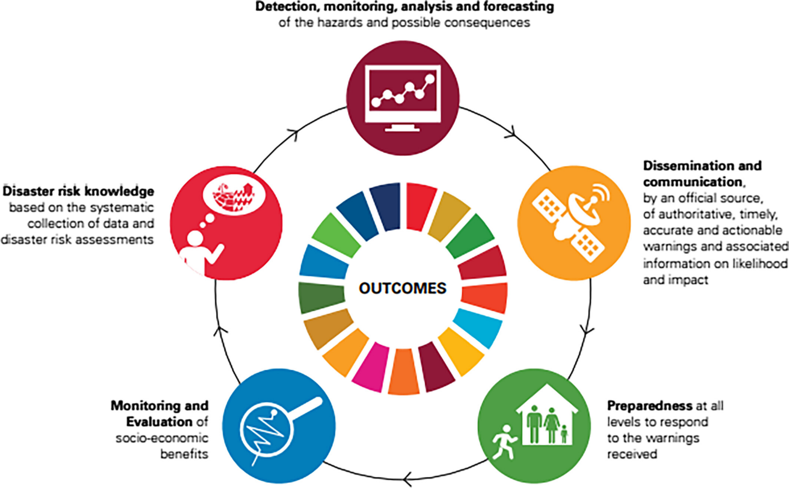

A real-time flood monitoring and early warning system can significantly enhance public safety and emergency response coordination in several ways:

* **Early Warning**: The system can detect and predict flooding well in advance, allowing for early warnings to be issued to the public and relevant authorities. This early warning provides crucial time for people to take proactive measures to protect themselves, their families, and their property.
* **Timely Evacuation:** Flood warnings enable timely evacuation of at-risk areas. Residents can be informed about evacuation routes, shelter locations, and safety procedures, reducing the risk of people being trapped in dangerous situations.
* **Emergency Services Deployment:** Emergency responders can prepare and deploy resources to areas in need before flooding occurs. This proactive approach enhances their ability to conduct rescue operations and provide medical assistance swiftly.
* **Resource Allocation:** The system helps in efficient resource allocation, such as deploying rescue boats, helicopters, medical teams, and supplies to areas that are expected to be most affected. This ensures that resources are used where they are needed the most.
* **Traffic Management:** Real-time information on flooded roads and bridges allows traffic management authorities to reroute vehicles and prevent accidents. This coordination ensures the safe movement of people during evacuations and emergency response efforts.
* **Infrastructure Protection:** The system can trigger the closing of flood gates, diversion of water, and other infrastructure protection measures to minimize damage to critical assets, including power plants, transportation hubs, and communication facilities.
* **Data-Driven Decisions:** Decision-makers have access to real-time data and analysis, enabling informed and data-driven decisions for flood response and mitigation efforts.
* **Public Awareness:** Public safety campaigns and awareness efforts can be reinforced through the system, educating the public on flood risks, preparedness, and response. When people are well-informed, they are more likely to act responsibly during flood events.
* **Community Engagement:** The system fosters community engagement by allowing the public to report emergencies, request assistance, and share real-time information. This interaction can enhance cooperation and coordination.
* **Data Sharing:** Emergency response agencies, local authorities, and neighboring communities can share critical flood information, alerts, and resources, fostering regional coordination and support.
* **Continuous Monitoring:** The system's real-time monitoring capabilities ensure that response efforts can be adapted and refined as flood situations evolve. This agility is vital for keeping response efforts effective.
* **Post-Event Assessment:** After the flood event, the system's historical data can be used to assess the impact, evaluate the effectiveness of response measures, and improve future response strategies.
* **International Collaboration**: In the case of transboundary rivers and cross-border flood risks, international coordination and data sharing become critical. Real-time systems facilitate such collaboration for a broader safety net.

In summary, a real-time flood monitoring and early warning system enhances public safety by providing timely information and facilitates coordinated responses to mitigate the impact of floods. This technology empowers emergency responders, local authorities, and communities to work together more effectively, ultimately saving lives and minimizing property damage during flood events.

**EXAMPLE OUTPUTS OF IOT SENSOR DATA TRANSMISSION AND PLATFORM UI FOR FLOOD PREDICTION MODEL**

For a flood prediction model, the outputs from IoT sensor data transmission and the platform user interface (UI) are critical for informing users and authorities about potential flood events. Below are example outputs for both aspects of the system:

**Example Outputs of IoT Sensor Data Transmission:**

**Water Level Sensor Data:**

Sensor Data: "Water Level: 195 cm"

Timestamp: "Timestamp: 2023-10-25 15:45:30"

Sensor Location: "Location: River XYZ"

**Rainfall Sensor Data:**

Sensor Data: "Rainfall: 20 mm/hr"

Timestamp: "Timestamp: 2023-10-25 15:45:30"

**Sensor Location:**

"Location: Station ABC"

**Weather Station Data:**

Temperature: "Temperature: 24°C"

Humidity: "Humidity: 68%"

Wind Speed: "Wind Speed: 10 km/h"

Timestamp: "Timestamp: 2023-10-25 15:45:30"

Sensor Location: "Location: Weather Station 123"

**Data Quality Alerts:**

Alert Type: "Data Quality Alert"

Sensor Location: "Location: River XYZ"

Alert Message: "Sensor calibration needed for water level data."

**Python code for IoT sensor data transmission:**

import requests

import json

import time

API_URL = "https://example.com/api/flood_prediction"

def send_sensor_data(water_level):

"""Sends the current water level data to the flood prediction API.

Args:

water_level: The current water level in meters.

"""

# Create a JSON object with the water level data.

data = {

"water_level": water_level

}

# Send the JSON object to the flood prediction API.

response = requests.post(API_URL, json=data)

# Check if the response was successful.

if response.status_code != 200:

raise Exception("Failed to send the sensor data to the flood prediction API.")

if __name__ == "__main__":

while True:

# Read the water level data from the IoT sensors.

water_level = read_water_level_from_sensors()

# Send the water level data to the flood prediction API.

send_sensor_data(water_level)

# Wait for 10 seconds before reading the water level data again.

time.sleep(10)

This code will continuously read the water level data from the IoT sensors and send it to the flood prediction API.

**Example Outputs in the Flood Prediction Platform UI:**

**Real-time Sensor Data:**

Graphs and charts displaying real-time sensor data, such as water level, rainfall, and weather conditions.

**Flood Prediction Alerts:**

Alert Type: "Flood Prediction Alert"

Location: "Location: River XYZ"

Alert Level: "Alert Level: Moderate"

Timestamp: "Timestamp: 2023-10-25 15:50:00"

Description: "High water levels indicate a potential flood. Monitor the situation closely."

**Historical Data Analysis:**

Trend analysis charts showing historical water level data and rainfall trends.

Anomaly detection alerts for unusual data patterns.

**Predictive Analytics:**

Predicted flood risk level: "Risk Level: Low/Moderate/High"

Forecasted time to flood: "Estimated Time to Flood: 6 hours."

**User Interface for Authorities:**

Special access for authorities to view and act on flood predictions.

Alert confirmation and response options for emergency services.

**User Alerts and Notifications:**

Notification panel for users to receive flood alerts via email, SMS, or in-app notifications.

Ability for users to set alert thresholds and preferences.

**Data Visualization on a Map:**

Map displaying sensor locations, flood-prone areas, and real-time sensor data.

Color-coded markers to indicate flood risk levels.

**Emergency Response Plan:**

Evacuation routes, shelter locations, and contact information for emergency services.

**Historical Data Records:**

Access to historical sensor data and predictions for analysis and reporting.

**Data Sources and Sensors:**

Information about the sensors and data sources used in the system.

**Python program of Platform UI for flood prediction model:**

import tkinter as tk

import requests

import json

class FloodPredictionPlatformUI(tk.Frame):

def __init__(self, master):

tk.Frame.__init__(self, master)

# Create a label to display the current water level.

self.water_level_label = tk.Label(self, text="Current water level: 0.0 meters")

# Create a label to display the flood probability.

self.flood_probability_label = tk.Label(self, text="Flood probability: 0.0")

# Pack the labels.

self.water_level_label.pack()

self.flood_probability_label.pack()

# Get the current water level from the flood prediction API.

water_level = get_current_water_level()

# Calculate the flood probability.

flood_probability = predict_flood_probability(water_level)

# Update the labels.

self.water_level_label.config(text="Current water level: {} meters".format(water_level))

self.flood_probability_label.config(text="Flood probability: {}".format(flood_probability))

# Schedule an update to the UI in 10 seconds.

self.after(10000, self.update)

def update(self):

# Get the current water level from the flood prediction API.

water_level = get_current_water_level()

# Calculate the flood probability.

flood_probability = predict_flood_probability(water_level)

# Update the labels.

self.water_level_label.config(text="Current water level: {} meters".format(water_level))

self.flood_probability_label.config(text="Flood probability: {}".format(flood_probability))

# Schedule an update to the UI in 10 seconds.

self.after(10000, self.update)

if __name__ == "__main__":

root = tk.Tk()

# Create the flood prediction platform UI.

ui = FloodPredictionPlatformUI(root)

# Start the mainloop.

root.mainloop()

This code will create a simple platform UI that displays the current water level and the flood probability. The UI will be updated every 10 seconds.

These outputs and the platform UI play a critical role in providing accurate information, warnings, and predictions to users, authorities, and emergency responders. The goal is to enhance preparedness, safety, and the ability to respond effectively to potential flood events.

**ADVANTAGES:**

Flood monitoring and early warning systems offer a range of advantages, making them essential tools for public safety and disaster preparedness. Some of the key advantages include:

* Risk Reduction: The primary advantage is the reduction of risks associated with flooding. Early warnings provide communities and individuals with vital information to take precautionary measures, evacuate if necessary, and protect lives and property.
* Improved Safety: By providing timely flood warnings, these systems enhance public safety. People can be informed well in advance, allowing them to make informed decisions and take actions to avoid danger.
* Property Protection: Early warnings enable individuals to safeguard their homes, belongings, and businesses. This helps minimize property damage and financial losses during flood events.
* Emergency Response Coordination: Flood monitoring systems support better coordination among emergency responders, local authorities, and disaster management agencies. This ensures a more efficient and organized response to flood events.
* Resource Allocation: The systems help allocate resources, such as emergency personnel, equipment, and supplies, to areas most in need during a flood. This optimized resource allocation improves response effectiveness.
* Infrastructure Resilience: Flood monitoring systems can trigger infrastructure protection mechanisms, such as closing flood gates, activating levees, or rerouting water. This helps preserve critical infrastructure like power plants, transportation networks, and communication facilities.
* Traffic Management: Real-time data on flooded roads and bridges allows traffic authorities to reroute vehicles and prevent accidents, ensuring the safe movement of people during evacuations and emergency response efforts.
* Data-Driven Decision-Making: Decision-makers have access to real-time data and analysis, enabling informed decisions for flood response and mitigation efforts. Data-driven decision-making leads to more effective outcomes.
* Public Awareness: Public safety campaigns and awareness efforts can be reinforced through these systems. Educating the public on flood risks, preparedness, and response ensures that people are well-informed and can act responsibly during flood events.
* Community Engagement: The systems promote community engagement by allowing the public to report emergencies, request assistance, and share real-time information. This engagement enhances cooperation and coordination.
* Continuous Monitoring: Real-time monitoring capabilities ensure that response efforts can be adapted and refined as flood situations evolve. This agility is vital for keeping response efforts effective.
* Post-Event Assessment: After the flood event, the systems' historical data can be used to assess the impact, evaluate the effectiveness of response measures, and improve future response strategies.
* Environmental Protection: By issuing early warnings, these systems also contribute to the protection of the natural environment, including wildlife and ecosystems, by allowing for proactive measures.
* International Collaboration: In cases of transboundary rivers and cross-border flood risks, international coordination and data sharing become critical. Flood monitoring systems facilitate such collaboration for a broader safety net.
* Public Confidence: The presence of a robust flood monitoring and early warning system instills confidence in the community, as people trust that their safety is a priority and that there is a plan in place to address flood risks.

Flood monitoring and early warning systems play a pivotal role in enhancing disaster preparedness, public safety, and coordinated response efforts. Their advantages extend to risk reduction, safety improvement, property protection, and resource optimization, contributing to a more resilient and secure community.

**DISADVANTAGES:**

While flood monitoring and early warning systems offer numerous advantages, they also come with certain disadvantages and challenges that need to be considered for effective implementation. Some of the disadvantages include:

* Cost of Implementation: Developing and maintaining a robust flood monitoring and early warning system can be expensive. Costs are associated with sensor deployment, infrastructure setup, data analysis, software development, and ongoing maintenance.
* Data Accuracy: The accuracy of the system heavily depends on the quality of sensor data. Sensor malfunctions, calibration issues, or inaccuracies in data collection can lead to false alarms or missed warnings.
* Sensor Maintenance: Sensors require regular maintenance and calibration to ensure accurate data collection. Neglecting maintenance can lead to data inaccuracies and system failures.
* Limited Coverage: The effectiveness of the system is limited by the geographical coverage of the sensors. Remote or sparsely populated areas may not have adequate sensor coverage.
* Sensor Vulnerability: Sensors can be vulnerable to extreme weather conditions, flooding, vandalism, and theft. Protecting sensors and ensuring their continuous operation can be a challenge.
* Data Transmission and Connectivity: The reliability of data transmission from sensors to the central system depends on the chosen communication infrastructure. Connectivity issues, network outages, or interference can disrupt data flow.
* Data Privacy and Security: Handling sensitive flood data raises concerns about data privacy and security. Unauthorized access to the system or data breaches can have serious consequences.
* False Alarms: Overly sensitive sensors or flawed data analysis can trigger false alarms, potentially leading to public skepticism and complacency in response to warnings.
* Warning Fatigue: Frequent false alarms or warnings for minor events can lead to "warning fatigue" among the public, causing people to disregard or underestimate the significance of warnings.
* Response Time: Despite early warnings, there may be limitations in the response time for individuals and authorities to take appropriate actions, especially in densely populated urban areas.
* Technology Dependence: Relying heavily on technology makes the system vulnerable to technical failures, power outages, and cyberattacks.
* Community Engagement: Ensuring that the public is aware of and understands the warnings and knows how to respond appropriately can be challenging. Effective public education and engagement are crucial.
* Communication Infrastructure: The choice of communication infrastructure may be limited by the availability of suitable technologies in certain areas, potentially hindering the implementation of the system.
* Operational and Maintenance Challenges: Ongoing operation and maintenance require a dedicated workforce and resources. Ensuring that the system remains operational and up-to-date can be a logistical challenge.
* Environmental Impact: The deployment of sensors and communication infrastructure may have environmental implications, such as land use and power consumption.
* Regulatory Compliance: Compliance with data privacy and environmental regulations adds complexity to system deployment and operation.

While flood monitoring and early warning systems offer valuable benefits in mitigating flood risks, these disadvantages and challenges underscore the importance of careful planning, investment, maintenance, and community involvement to maximize their effectiveness and reliability.

**BENEFITS:**

The benefits of using flood monitoring and early warning systems are significant and wide-ranging, impacting public safety, property protection, and disaster preparedness. Here are some of the key benefits:

* Early Warning: The primary benefit is early warning. These systems can detect flood events well in advance, providing critical time for individuals, communities, and authorities to prepare and take preventive actions.
* Public Safety: Flood warnings enhance public safety by alerting individuals and communities to potential flood risks. This empowers people to make informed decisions and take steps to protect themselves and their families.
* Property Protection: Individuals and businesses can use flood warnings to safeguard their homes, assets, and infrastructure, reducing property damage and financial losses.
* Emergency Response Coordination: Early warnings improve the coordination of emergency response efforts. Authorities can deploy resources, personnel, and services to areas in need before flooding occurs, ensuring a more effective response.
* Resource Allocation: Efficient resource allocation is made possible, as authorities can allocate resources such as emergency personnel, equipment, and supplies to areas where they are most needed during a flood event.
* Infrastructure Resilience: Flood monitoring systems enable the activation of infrastructure protection mechanisms, such as closing flood gates, diverting water, and reinforcing levees, to minimize damage to critical assets.
* Traffic Management: Real-time data on flooded roads and bridges allows traffic management authorities to reroute vehicles, preventing accidents and ensuring the safe movement of people during evacuations and emergency response efforts.
* Data-Driven Decision-Making: Decision-makers have access to real-time data and analysis, allowing them to make informed decisions regarding flood response and mitigation efforts.
* Public Awareness: Public safety campaigns and awareness efforts can be reinforced through these systems. Education about flood risks, preparedness, and response helps ensure the public is well-informed and can act responsibly during flood events.
* Community Engagement: These systems facilitate community engagement by allowing the public to report emergencies, request assistance, and share real-time information. This interaction enhances cooperation and coordination.
* Continuous Monitoring: Real-time monitoring capabilities ensure response efforts can be adapted and refined as flood situations evolve, contributing to more effective response and recovery efforts.
* Post-Event Assessment: After a flood event, the systems' historical data can be used to assess the impact, evaluate the effectiveness of response measures, and improve future response strategies.
* Environmental Protection: Early warnings and preparedness measures can extend to the protection of the natural environment, including wildlife and ecosystems, by allowing for proactive measures.
* International Collaboration: In cases of transboundary rivers and cross-border flood risks, international coordination and data sharing become critical. These systems facilitate such collaboration for a broader safety net.
* Public Confidence: The presence of a robust flood monitoring and early warning system instills confidence in the community. People trust that their safety is a priority and that there is a plan in place to address flood risks.

Flood monitoring and early warning systems offer a range of benefits that are essential for public safety, property protection, and coordinated disaster preparedness and response. These systems contribute to the resilience and security of communities in flood-prone areas.

**CONCLUSION:**

In conclusion, flood monitoring and early warning systems play a pivotal role in mitigating the devastating impacts of flooding events. These systems are a critical component of disaster preparedness, public safety, and effective emergency response. By providing early warnings, real-time data, and coordination tools, they empower communities, individuals, and authorities to make informed decisions and take timely actions to protect lives, property, and the environment.

The advantages of flood monitoring and early warning systems are clear, ranging from risk reduction and property protection to efficient resource allocation and improved public safety. These systems contribute to a more resilient and responsive society in the face of one of the world's most common and destructive natural disasters.

However, it is important to acknowledge the challenges and disadvantages associated with these systems, such as the costs of implementation, data accuracy, and the need for ongoing maintenance. Overcoming these challenges requires commitment, investment, and a collaborative effort from various stakeholders.

In a world where climate change and extreme weather events are becoming more frequent, the importance of flood monitoring and early warning systems cannot be overstated. These systems provide a safety net, offering hope, protection, and the possibility of minimizing the devastating impact of flooding on our communities.

In summary, flood monitoring and early warning systems are not only technical solutions but also symbols of our collective responsibility to protect and support one another in the face of nature's forces. Through their implementation and continuous improvement, we strengthen our ability to face the challenges posed by flooding and build safer, more resilient communities.